Grade 2 Science Unit Plan

Focus: Metamorphosis

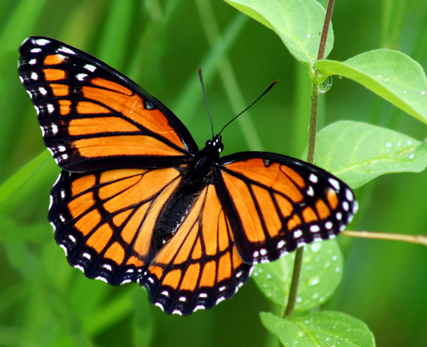

EDCI 403 (A01)
Kiddell
November 22, 2018

Curricular Connections

Subject | Big Ideas | Content and Elaborations
Science | Living things have life cycles adapted to their environment | Metamorphic  - Metamorphic life cycles: body structure changes (e.g., caterpillar to butterfly, mealworm transformation, tadpoles to frog)  and Non-metamorphic  - Non-metamorphic life cycles: organism keeps same body structure through life but size changes (e.g., humans)  - Life cycles of different organisms
ELA |  | Elements of story  - character, plot, setting, structure (beginning, middle, end), and dialogue  Language features, structures, and conventions  - Letter formation  - Legible printing with spacing between words  - Sentence structure  - The structure of compound sentences
P.E. |  | proper technique for fundamental movement skills, including non-locomotor, locomotor, and manipulative skills
Social Studies | Local actions have global consequences, and global actions have local consequences.  relationships between people and the environment in different communities | - impact of different economic activities and ways of life on the environment  - impact on the environment by small and large communities  - impact of recreational activities on the environment  - community values regarding conservation and protection of the environment
Arts Education | Dance, drama, music, and visual arts are each unique languages for creating and communicating.
Class 1: Metamorphosis Intro
- Playdough Fun
- Students make one object/ thing... anything they want… do not tell them you are doing metamorphosis
- Now, make something completely different, but with the same bits of clay, colors etc. that you did before!
Debrief: You have demonstrated the process of metamorphosis! Show them the butterflies in the terrarium…ask students that they think is inside... you will be hatching them! (Entire hatching process takes 1 month)
- Define metamorphosis: (in an insect or amphibian) the process of transformation from an immature form to an adult form in two or more distinct stages (Retrieved from https://en.oxforddictionaries.com/definition/metamorphosis)

Class 2: Metamorphic vs. Non-metamorphic
- Redefine metamorphosis
- Compare and contrast living creatures that do and do not go through metamorphosis (e.g. butterfly vs. human); do this on a Venn Diagram
- Write down, as a class, as many things as you can think of that undergo metamorphosis

Class 3: Butterfly Lesson 1 & Craft
- What is everything you know about butterflies? Write this down on a chart in front of the class!
- Make butterfly craft to hang around the classroom
- Supplies: coffee filters, pipe cleaners, different colors of dye, droppers
- Pinch the coffee filter in the middle; wrap pipe cleaner around it, twist at the top for antennae
- Drop different colors of dye on the filter and watch it spread/ mix!

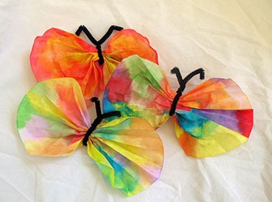
Retrieved from: https://www.parenting.com/article/coffee-filter-butterfly

Class 4: Butterfly Lesson 2- Life Cycle Stage Identification & Scene Creation
- Watch the following butterfly metamorphosis video: https://www.youtube.com/watch?v=8rvGUevGxDk
- Complete the worksheet below
- Once the worksheet is finished, cut out the 4 stages of the butterfly, draw an outdoor scene on a blank sheet of paper, and paste the butterfly in its stages onto the paper!
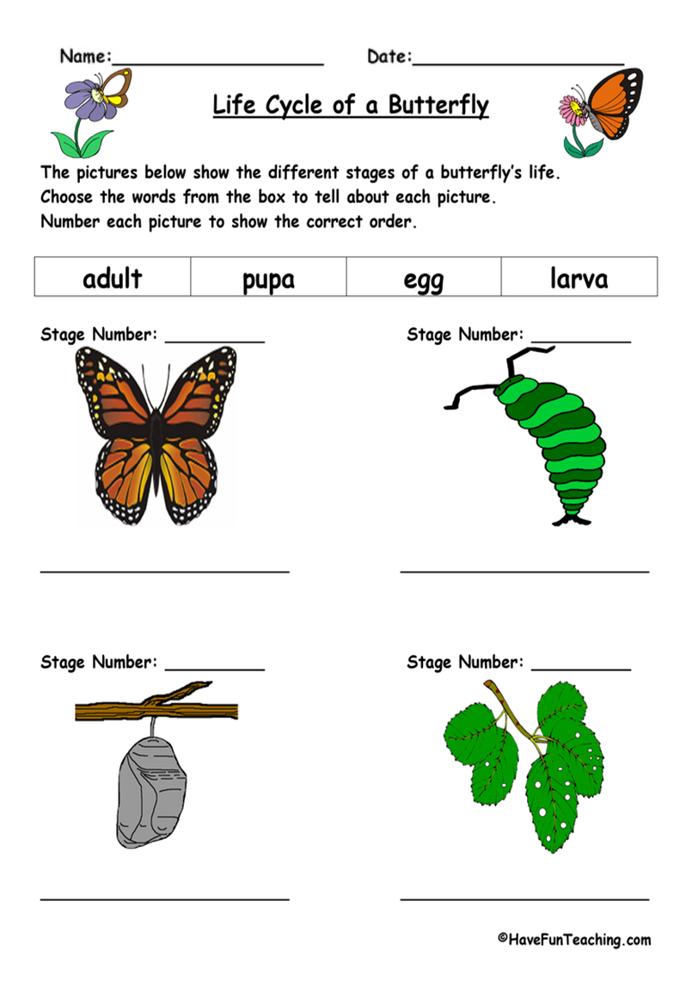
Retrieved from https://goo.gl/images/TsJbvr

Class 5: Study of Other Animals that Metamorphose- Students Choice
- Ask students: do you know any other living creatures that metamorphose? Frogs, moths, spiders, scorpions, bees, ants
- Class vote! Students all write their first and second choices of the 2 other metamorphosing animals we will study
- KWL chart: “Know, Want to Know, Learned” about the 2 creatures

Class 6: Study of other Metamorphosing Animals #1
- Fill out K & W sections before
- Read a book about the living creature/ activities
- Fill out L section after

Class 7: Study of other Metamorphosing Animals #2
- Fill out K & W sections before
- Read a book/ watch a video about the living creature
- Fill out L section after

Class 8: Metamorphic Story Making
- Write a metamorphosis story! This must include the following: elements of a story (character, plot, setting, structure- beginning, middle, end, and dialogue), and can be done individually or with partners

Class 9: Endangerment of Metamorphosing Creatures
- Research project using available technology- how are metamorphosing creatures endangered?

Class 10: What Can Humans Do to Help?
- Research period using available technology- what are actions we can take as humans to help?

Class 11: Brainstorming for Summative Project/ Debrief for Field Trip
- Brainstorming class: summative project ideas for metamorphosis dance/sports routine for P.E.
Metamorphosis Dance/ Sports routine:
- Students will create a dance or sports sequence, with appropriate music, that demonstrates metamorphosis or with focus to one specific metamorphosing creature
- Can use any gym props: soccer ball, baseball supplies, mats, scarves, hula hoops, skipping ropes...
- Reminder/ debrief for field trip tomorrow: things to know/ bring (these would also be outlined on their field trip form which would have gone out at the beginning of the unit)

Class 12: Full Day Field Trip to Victoria Butterfly Gardens
- Trip to Victoria Butterfly Gardens
- Admission $6 for students 5-12 years of age
- Go around in groups supervised by parent volunteers
- Observe everything you can!
- Fill out “Student Explorations!” sheet
- See lesson plan below on pp. 6-8

Class 13: Metamorphosis Unit Debrief/ Chart
- Debrief on everything you learned about in the gardens and from the unit….
- Write down everything you now know about metamorphosis on another piece of chart paper and put it next to the one from day 1! Then students can better visually see what they have learned.

Class 14: Summative Project Work Period
- Work period for metamorphosis dances/ sports routines in gym

Class 15: Summative Project Performance
- Performance of metamorphosis dances/ sports routines in gym!
- Students will be assessed here!

Ideas for time-fillers (if classes go too fast)
- Butterfly documentaries...metamorphosis videos...
- Discuss different types of butterflies; monarch
- Read book about metamorphosis

LESSON TITLE: Field Trip to Victoria Butterfly Gardens!

Grade | 2 | Subject | Science; metamorphosis; Lesson 12/15
Date |  | Allotted Time | Entire day- leave for gardens after snack at 10 am, return at end of school day at 2:50 pm

RATIONALE: Student learning for the metamorphosis unit will be consolidated through this exploration of the Butterfly Gardens!

KEY QUESTIONS:

What things did you see that you learned in the unit?
What new questions do you have from what you saw?
Can you represent your learning in drawings?

CORE COMPETENCIES: Communication (C), Thinking (T), Personal & Social (PS)

C- Connect and engage with others (to share and develop ideas); acquire, interpret, and present information
T- Generating ideas
PS- Show a sense of accomplishment

BIG IDEAS: Living things have life cycles adapted to their environment

ASSESSMENT: Students have filled out the “Student Explorations!” sheet and are engaged with explorations. Prior knowledge of metamorphosis from the unit should be more than enough for the field trip to be a meaningful experience.

FIRST PEOPLES PRINCIPLES OF LEARNING:

Learning is holistic, reflexive, reflective, experiential, and relational (focused on connectedness, on reciprocal relationships, and a sense of place).

Resources/ Materials
- “Student Explorations!” sheets for students
- Clipboards, pens/ pencils
- Mini First Aid kit
- Teacher binder (with class list from the day, contact information etc.)

Preparation
- Field trip forms created, filled out by parents, returned
- Money collected and paid to gardens in advance
- “Student Explorations!” sheets
- Bus booked
- Reminder gone out the day before regarding what to bring
- Parent volunteers organized; require 1 per roughly 8 students = minimum 3 volunteers

Sequence of Events | Approximate Time
Morning at school  Students arrive, ensure they have all their belongings, take attendance, have snack  Butterfly Gardens!  Bus arrives  Arrival at gardens  Rules set including:  - Meeting place for lunch  - Etiquette for field trip: no running, respect things, do not touch butterflies, keep voices at a manageable level  - Break into groups with parent/ adult volunteers!  Explorations  - Students will explore the gardens with their group leader and fill out Student Explorations! sheet  Meet for lunch  Afternoon explorations  - Explorations continue...  Back on bus  - All students accounted for  Arrival back at school  - Quick debrief on day! | 8:40- 10 am  10 am  10:30 am  10:30-10:45 am  10:45- 12:00 pm  12:00- 12:30 pm  12:30- 1:45 pm  2:00 pm  2:30-2:50 pm
ACCOMMODATIONS
- Students who struggle with writing may have the adult leader help them
- If students cannot attend the field trip, they will be given a fun metamorphosis movie/ video to watch and can fill out a similar chart to “Student Explorations!” one

EXTENSIONS
- Students can return to class with new questions and pursue those with an inquiry project/ integrate them into their final summative project

CROSS-CURRICULAR INTEGRATION
- ELA: writing experiences and observations
- Art: drawing experiences and observations

Student Explorations!
 | Observation 1 | Observation 2 | Observation 3
Drawing:

Written Explanation:

New questions?
Comments by another classmate:

